Project Design Phase-II
AI FitTrack – Data Flow Diagram & User Stories
Date | 24 September 2026
Team ID | SWTID-2026-9501
Project Name | AI FitTrack – AI-Powered Fitness Tracking System
Maximum Marks | 4 Marks
Data Flow Diagrams:
A Data Flow Diagram (DFD) shows how user requests and fitness data move through the React client, Express API, authentication middleware, controllers, services, MongoDB Atlas and Gemini.
Example: DFD Level 0 (Industry Standard)
AI FitTrack DFD: User → React Client / Thunder Client → Express REST API → Controller → MongoDB Atlas or Gemini → JSON Response.(Simplified)

User Stories
Use the below template to list all the user stories for the product.
User Type | Functional Requirement (Epic) | User Story Number | User Story / Task | Acceptance criteria | Priority | Release
Fitness User | Authentication | US-01 | As a user, I can register using name, email and password. | A valid user is created and a token is returned. | High | Sprint-1
Fitness User | Authentication | US-02 | As a user, I can log in with email and password. | Valid credentials return a JWT; invalid credentials are rejected. | High | Sprint-1
Fitness User | Profile | US-03 | As a user, I can view and update my fitness profile. | Profile data is returned and valid updates are persisted. | High | Sprint-1
Fitness User | Workout Tracking | US-04 | As a user, I can add a workout. | A workout is stored against the authenticated user. | High | Sprint-2
Fitness User | Workout Tracking | US-05 | As a user, I can view and search my workouts. | Only the user's records are returned and filters work. | High | Sprint-2
Fitness User | Workout Tracking | US-06 | As a user, I can update or delete my workout. | Only an owned workout can be changed or removed. | High | Sprint-2
Fitness User | Dashboard | US-07 | As a user, I can view activity analytics. | Totals, average, streak, categories and recent records are shown. | High | Sprint-3
Fitness User | AI Coaching | US-08 | As a user, I can request a personalized workout recommendation. | The AI route returns a recommendation when provider access is available. | High | Sprint-4
Fitness User | AI Coaching | US-09 | As a user, I can request fitness insights. | The AI route returns analysis from submitted metrics. | Medium | Sprint-4
Administrator | Operations | US-10 | As an operator, I can verify API health and errors. | Health and structured error responses are available for support. | Medium | Sprint-4
Level-0 Data Flow
External entities: Fitness User and Google Gemini service. Main processes: Authentication, Workout Management, Dashboard Analytics and AI Coaching. Data stores: Users and Workouts in MongoDB Atlas.
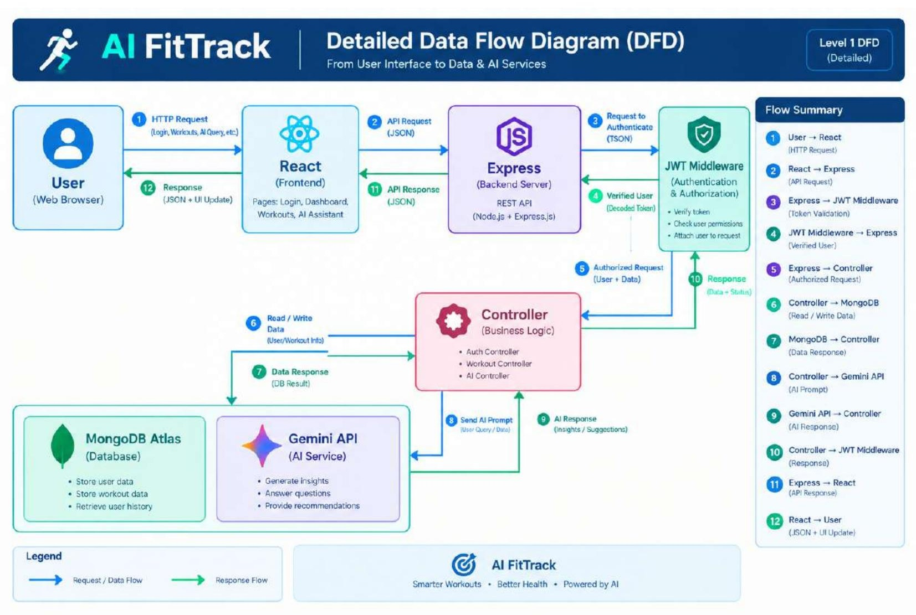
Level-1 Data Flow – AI Coaching
The AI flow validates the authenticated request, constructs the recommendation/insight prompt, invokes the Gemini service, receives generated content and returns a controlled JSON response. Provider failures are surfaced as application errors.
